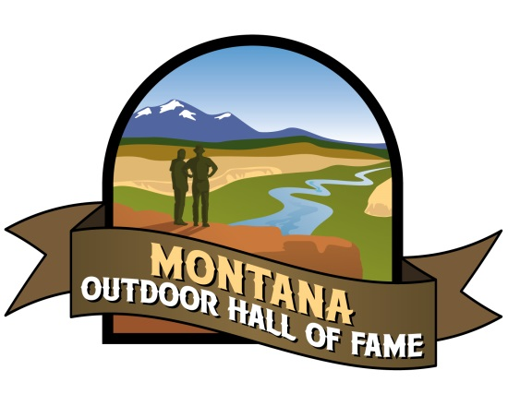
Montana Outdoor Hall of Fame
Nominee Application

Thank you for your interest in helping recognize the outstanding contributions people have made to the restoration, conservation, and protection of our great Montana outdoors and its amenities. Every two years, the Montana Outdoor Hall of Fame seeks to induct a diverse group of highly qualified and worthy individuals.

Applicants do not have to be living nor do they have to be a resident of Montana as long as they have spent some time in Montana and the impact to Montana was significant. APPLICATIONS ARE DUE BY DECEMBER 31, 2017 AND CAN BE SUBMITTED ANYTIME.

If you would like to add one (optional) supporting document to the application, it will be used by the selection committee for consideration. However, we cannot accept more than one supporting document and cannot guarantee return of the documents. Please complete the following questions.

Nominee Name: _______________________________________________________
Living _________ Deceased __________ Year deceased:___________________
Nominee Address: ____________________________________________________
____________________________________________________
Nominee Telephone: _____________________________________________________
Nominee Email: __________________________________________________________
Closest Living Relative: ____________________________________________________
Contact Information of the closest living relative: ______________________________________________________
_____________________________________________________
- How has the nominee made significant contributions to the restoration, conservation, and protection of wild animals, wild rivers, wild landscapes for the enjoyment of the people in Montana? (Please limit to 250 words)

- Has the nominee’s accomplishments been of such a nature to be of lasting significance for Montana and its people? Explain. (Please limit to 150 words)
- In what way, do the nominee’s accomplishments stand out in your mind? What is different and unique about the way this nominee achieved success? (150 words or less)
- What other information would you like to share about this nominee? (limit to 150 words)

Application submitted by: __________________________________________________
Email:_________________________________________________________________
Phone: _________________________________________________________________________
Address: ________________________________________________________________________

Send application to: Ariel Rademaker ariel.halloffame@gmail.com
or mail to Montana’s Outdoor Legacy Foundation, PO Box 220, Columbia Falls, MT 59912

