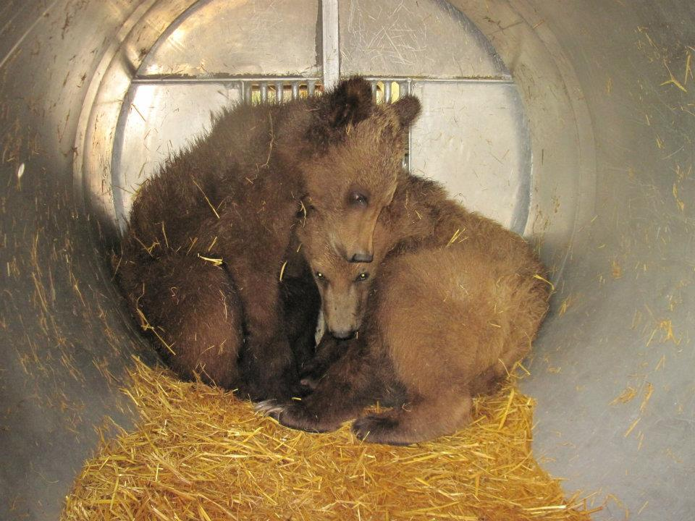
The long term recovery of Grizzlies is dependent on co-existence with humans. This requires consistent education about these magnificent animals and how best to keep both humans and animals safe. Original eradication of these magnificent animals came at the hands of humans out of fear, conflicts and territory. Even today we do not tolerate loss of life, livestock or pets from these animals.
As an excerpt from the Flathead Beacon indicated, “Reports of a 575-pound adult male grizzly bear that was damaging private property in the Coram area prompted wildlife officials to capture and kill the bruin, which had become conditioned to human food, Montana Fish, Wildlife and Parks officials said Friday.” Or in September 2017, an FWP report includes:
“Specialists from USDA Wildlife Services, working in coordination a with Montana Fish, Wildlife and Parks’ (FWP) bear specialist, confirmed a grizzly was the cause of the depredation and at least 12 grizzly bears were in the area, including sows with cubs. This week, up and down the Rocky Mountain Front and areas east where creek bottoms provide the bears easy travel corridors to the prairie, bears are making their presence known. FWP bear specialists have responded to citizen complaints of bears eating apples around Choteau, Valier and residences east of Highway 287. Wildlife Services and FWP specialists have responded to bears killing livestock in several locations around central and southwest Montana this summer, including Madison, Carbon, Teton, Glacier, Pondera, and Lewis & Clark counties”
Incidents like agency officials announcing that a grizzly bear had broken out the back window of a truck to get horse feed, pried open a refrigerator on a porch, and tried getting into a slide-in camper along with getting into bee hives, grain elevators, dog food and other attractants are becoming common as both human and grizzly populations expand.
FWP personnel also receive second-hand reports of grizzly bears getting food rewards at other residences throughout Montana, but were never contacted by the landowners. In one case, a sow and two cubs were frequenting an area and the sow was teaching the cubs bad food gathering behavior. Eventually the sow had to be put down and the cubs were orphaned. Jack Hanna and Larry Wilson came together and helped FWP find a home for the cubs; however, the build out of their new zoo location took time and left FWP in quite the quandary.
“The worst part of my job is having to remove a grizzly bear from the population because it has become food-conditioned and starts causing property damage especially when cubs are involved,” Manley said.
Education is critical and zoos play a big role. They help the public move from fear to healthy respect. Thus, while our first option is always to keep grizzly cubs in the wild, zoos play a key role when that is impossible.
From 1993 to present, there have been over 100 management captures of grizzly bears involved in conflicts just along the Middle Fork of the Flathead River corridor between Hungry Horse and Marias Pass. As our grizzly bear population grows, orphaned grizzly cubs are discovered more frequently. In the past year alone, FWP dealt with four cubs. It is getting harder to find zoos that will take the cubs and those locations need a considerable amount of preparation time. This means that FWP has to hold these iconic animals for a longer period. Small traps work for very short periods of time, but when that time gets extended, they are no longer a viable or humane method to use. We need to build a suitable place to keep the cubs until a zoo is ready for them or when survival is possible relocate them back into the wild.
Introducing Montana WILD Rehab Center
Montana supports a wide range of wildlife and their habitats. One of FWP's more challenging responsibilities is caring for Montana's orphaned wildlife. In the early 1990's a new state-of-the-art facility that would give orphaned animals a second chance at being wild was constructed.
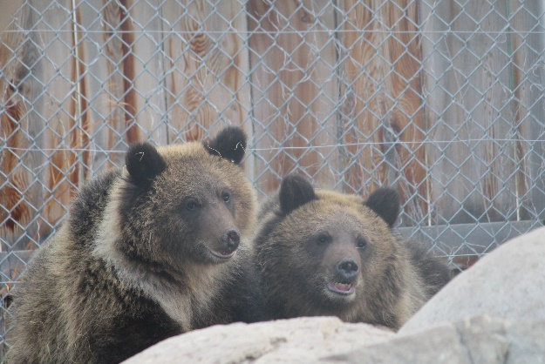
The Montana Wildlife Center rehabilitates orphaned wildlife for the purpose of release back to the wild, while offering visitors opportunities to learn about wildlife and the natural world in a
Grizzlies are very territorial, aggressive and large even as cubs. Thus, an addition to this facility would be needed to make a perfect place for grizzly cubs while FWP searches for permanent homes. The pen will be a place to care for and nurture grizzly cubs in a safe and humane environment until release is possible or until a permanent home can be found. It will not become a zoo and the public will not be able to see the grizzlies other than viewing via a remote camera at the Montana WILD facility. The cost estimate for this addition which will include an electronic gate suitable for the culvert trap to be backed up to in order to release the cubs, is $180,000. To date we have raised $40,000.

